LEP – Sub Committee

LEP - Lancashire Skills and Employment Board

Private and Confidential: NO

Wednesday, 11 April 2018

Lancashire Skills & Employment Hub update

Report Author: Dr Michele Lawty-Jones, Director of the Lancashire Skills & Employment Hub, michele.lawty-jones@lancashire.gov.uk & Lisa Moizer, Co-ordinator of the Lancashire Skills & Employment Hub lisa.moizer@lancashire.gov.uk

Executive Summary

This paper provides an overview of Lancashire Skills & Employment Hub activity since the last formal committee meeting.

Recommendation

The Lancashire Skills and Employment Board are asked to note the update.

1. Careers Education, Information, Advice and Guidance (CEIAG)
  - The Lancashire Enterprise Adviser Network has grown from 97 schools and colleges in mid-November 2017, to 120 at the end of February 2018. Of the 120, 113 have been matched with at least one volunteer business leader (Enterprise Adviser). A total of 134 Enterprise Advisers have signed up to the network.

  - In January, an event was held at Longridge High School with Edwin Booth and the Careers and Enterprise Company (CEC) to celebrate the 100th school to sign up. A press release was issued regarding the event, with example case studies for local areas of Lancashire. These were published in a range of local newspapers and business magazines, as well as on the CEC website. See here for details of the main press release:

https://www.lancashireskillshub.co.uk/news/lancashires-enterprise-adviser-network-reaches-key-milestone-longridge-high-school-partners-motion-lab-marketing-ltd/

  - The Enterprise Coordinators are in the process of moving schools and colleges to the new digital tools that have been developed by the CEC, which enable schools to assess progress against the Gatsby Benchmarks. The tools are called the Career Compass and Tracker (a development plan was previously in place). As of the end of February, 91 schools had undertaken the Career Compass assessment and 59 had adopted Tracker. This number will increase over the coming months. To-note there are a few administrative niggles that are currently being reviewed and addressed by CEC; this will further support the roll out of the tools to all schools and colleges in the Lancashire network. A version of Career Compass for the FE sector is also due to be launched in September 2018.

  - The Government's Careers Strategy was published in December 2017, and a summary previously circulated to the board. The Careers Strategy resulted in a strengthening of the statutory guidance, and a focus on building the role of the CEC, recognising success to-date in establishing a nation-wide network of Enterprise Advisers working with the LEPs.

  - The CEC published a draft Implementation Plan for consultation in early March - articulating how they intend to take forward aspects of the Careers Strategy, including the piloting of 'Career Hubs', the Career Leaders programme and the release of activity funds for employer encounters and funds to test guidance models. The Hub submitted a response to the consultation before the deadline on the 23rd March. Plans to bid for a pilot Career Hub in Lancashire are in development and will be discussed further at the meeting.

  - In relation to the Blackpool Opportunity Area (OA), a Priority 3 Delivery Group has now been established and has met three times. The group is chaired by the Skills Hub director and supported by the Blackpool OA programme team. Priority 3, as per previous updates, aims to improve advice and support for young people when moving between schools/colleges and into work. Key is coordination and maximising impact by bringing activities together to provide a coherent, planned approach across primary, secondary and post-16 education.

  - All 13 of the secondary schools (including the special schools and the pupil referral unit) and colleges in Blackpool are engaged in the Lancashire Enterprise Adviser Network, and are matched with local business leaders. This includes Westinghouse UK, the Royal Bank of Scotland, Hays Recruitment, Department of Work and Pensions (DWP), Blackpool Transport, The Winter Gardens, Hilton Hotels, Blackpool Football Club Community Trust and several micro-businesses/sole traders. From September to February pupils across Blackpool, from Years 7 to 13, received 9,137 employer encounters – this includes a wide variety of different activities, from mentoring, to workplace visits, to employer talks, to careers fairs.

  - During National Careers Week we held a spotlight on a number of our Enterprise Advisers from across the County to raise awareness of the network with the business community. All of the Enterprise Advisers spotlights are available to be viewed on the Lancashire Enterprise Adviser Network website: https://lancashireean.co.uk/latest-news/ - please do take the time to click through and view!

  - A celebration / development event for all schools and colleges across Lancashire and Enterprise Advisers is being planned for Friday 27th April. Claudia Harris, CEO of the CEC will be our key note, along with Ryan Gibson who spearheaded the North East pilot of the Gatsby benchmarks.

2. European Structural Investment Funds (ESIF)
2.1 The DWP appraisals of the stage 2 project submissions against Investment Priority 2.2 were reviewed at the ESIF Committee in January. The committee supported the strategic fit of both projects ('Upskilling Lancashire' and 'EnginE'). DWP are currently working with the project applicants, UCLan and Lancaster University respectively, to clarify final points raised by the appraisers. It is hoped that the projects will proceed to contract in the near future.
2.2 The DWP appraisal of the stage 1 project submission against Investment Priority 2.1 for the call relating to widening participation / underemployment was also reviewed at the ESIF Committee, and has now progressed to stage 2. The lead applicant is UCLan and the project is called 'Learning Engagement Lancashire'. UCLan and the consortium are currently developing the stage 2 application.
2.3 We are awaiting feedback from DWP on the appraisal of the stage 2 Leadership and Management project, 'Leading Lancashire' which was also submitted against Investment Priority 2.1 earlier in the year.
2.4 The proposed ESFA extensions, and recommendations from the Skills and Employment Board, were discussed at the ESIF Committee. The ESIF Committee were supportive of the recommendations; however, we are still awaiting formal confirmation from DWP and the ESFA. It is likely that extensions, if approved, will be wrapped into the April performance management point.
2.5 It has been confirmed that the Apprenticeship levy is eligible as match funding for ESF activity. This was introduced in a (very) brief guidance note before Christmas. Discussion has taken place with the ESFA, and a telekit has been subsequently held by the LEP Network with DWP and LEPs. Both have provided useful in developing local understanding with the Northwest Universities European Unit (NWUEU) and The Lancashire Colleges (TLC). Levy match is being considered in the current directly funded projects which are being processed, as well as to support the development of future project ideas for remaining 1.2 and 2.1 funds.
3. City Deal
3.1 The City Deal skills and employment 2016/17 final year report, which was shared at the last committee meeting, was presented at the City Deal Executive on Wednesday 29th November by the chair of the City Deal Skills & Employment Steering Group, Dr Lis Smith. The report was well received by members of the Executive. The A3 presentation of the case studies was particularly welcomed, and members were pleased at the variety of activities that had taken place.
3.2 As per discussion at the informal committee meeting in January, a post is being established to drive forward skills and employment across the Cuerden development site, as part of the broader City Deal area. The post is due to be advertised shortly and will be promoted via social media once released.
4. Events
4.1 Escalate
4.1.1 The Escalate on-line tool for searching ESF provision to support people on their journey into work has been launched on the Lancashire Skills Hub website: https://www.lancashireskillshub.co.uk/escalate/ This has been a fantastic partnership effort, facilitated through the Lancashire Adult Skills Forum, with a range of partners involved in a variety of task and finish groups, alongside financial contributions from a range of projects.
4.1.2 Six launch events have been held to-date across Lancashire, with a seventh due to take place on Thursday 29th March. The events have been hosted by a number of partners across Lancashire. The events have exceeded expectation, with over 400 people attending to-date (excluding market place attendees) and 57 booked onto the final event in Blackburn. The events, as well as launching the tool, have facilitated communications between both delivery partners and referral agencies; a number of partners saw immediate results following the event and received new referrals.
4.1.3 Comments from the graffiti board at the events included:
- Good to meet others from different projects - links for referrals and provision.
- Excellent networking opps. Good contact meeting arranged with potential referral organisation.
- Really worthwhile event - great for networking + to put faces to names. Managed to get 3 appointments to meet people.
- Great event launching a great product!
- Very Informative - found new agencies.
- Really good referral pathway will use in future.
- Excellent information and a wealth of useful support for our customers.
- Super website it will be extremely useful tool for adults, young people, employers and providers.
- Brilliant great-staff eager to help. Would have liked work club to be included on the website.
- Great event! Met some amazing people who can help me deliver my service and who I can signpost to.

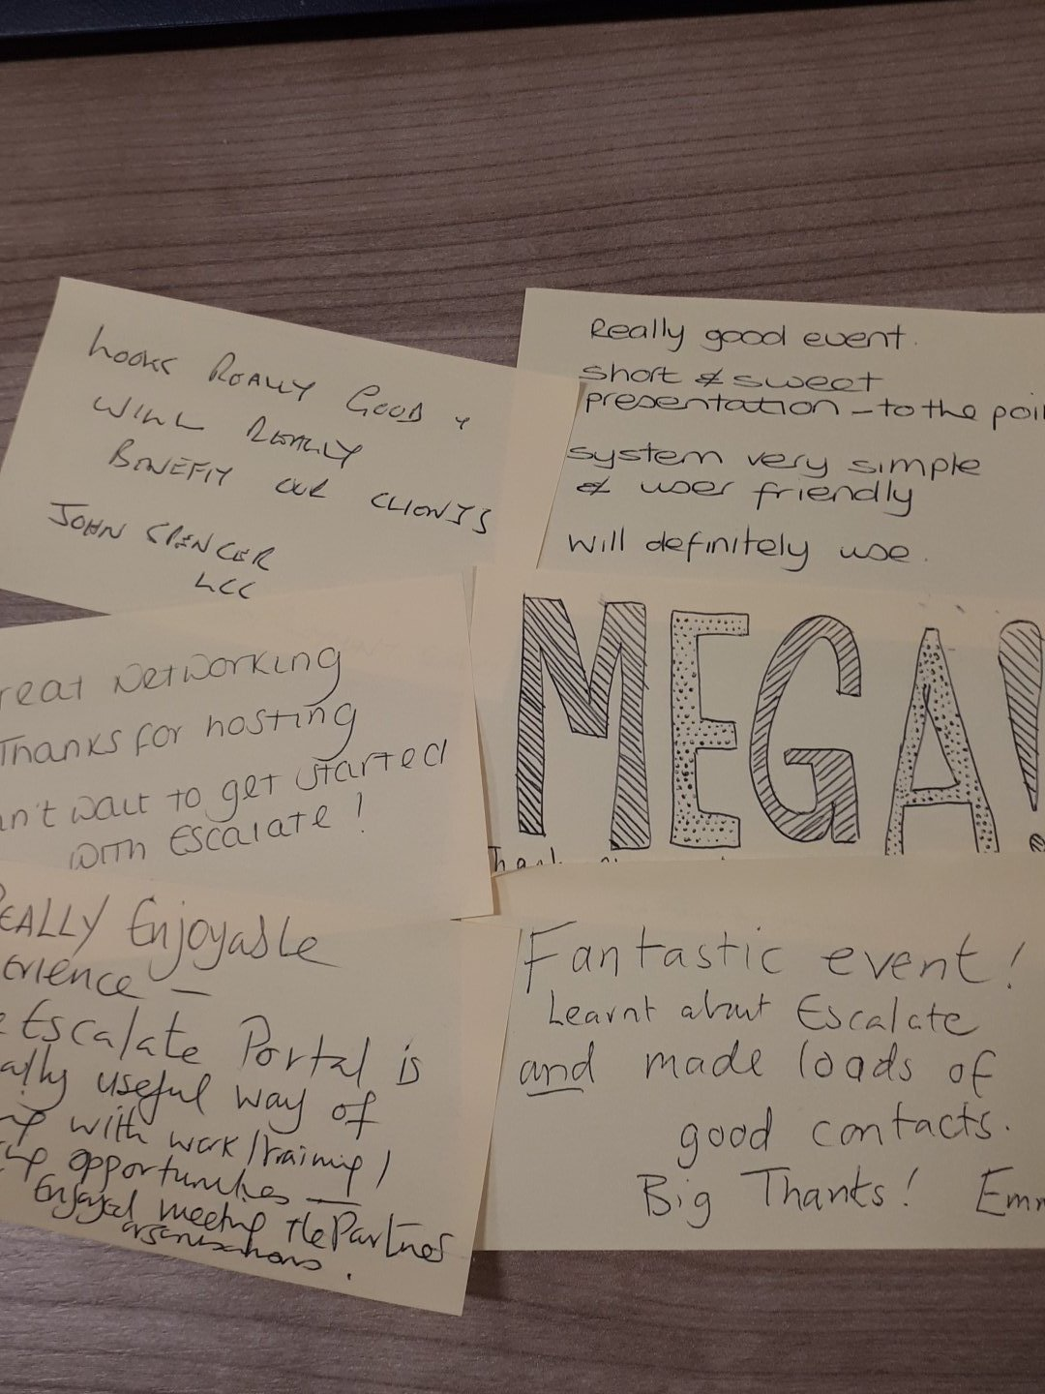
4.1.4 Feedback will continue to be gathered regarding the on-line tool, with view to developing Escalate further and including other provision, beyond that which is ESF funded.

4.2 Northern Powerhouse Partnership Conference
A Northern House Powerhouse Partnership Conference was held in October, to launch the Education and Skills Report. The Lancashire Enterprise Adviser Network is referenced in the report. The Hub was on the panel for the 'People's Powerhouse' discussing engagement of young people in the development of provision locally and the growth of the Enterprise Adviser Network and how this has impacted on young people's insight into the world of work.
4.3 Apprenticeships
The Hub was involved in a roundtable with BAE and the News Statesman, discussing the future of Apprenticeships and also featured in the latest LBV magazine which included a piece on Apprenticeships in Lancashire.
5.0 Growth Deal Programme
5.1 The Growth Deal Programme team continue to monitor the Growth Deal Skills Capital investments across the Lancashire area. All skills capital projects are currently RAG rated green, and the majority of completed the capital phase and are now collecting evidence of learner outputs.
5.2 The launch of the Lancashire Energy HQ at Blackpool and The Fylde College took place earlier in the month. The facility, which was part-funded through Growth Deal Skills Capital, was officially opened by the Northern Powerhouse Minister, Jake Berry MP. See here for the press release:
https://www.blackpool.ac.uk/news/08-03-2018/bfcs-lancashire-energy-hq-officially-opened-northern-powerhouse-minister
6. Technical Education – Visioning Piece
6.1 A draft of the Technical Education Vision for Lancashire was discussed at the informal committee meeting in January. A final draft has now been circulated to the sixty plus stakeholders that were involved in the development of the vision – either through an interview or via attendance at the workshops. A foreword to the report is being drafted from the chair of the LEP and the chair of the Skills and Employment Board, with view to the report being formally published on the LEP and Hub websites.
6.2 The Hub are currently in discussion with SDG regarding next steps and the development of the route map, reviewed at the last committee, and the development of an action plan. Consideration is being given as to whether further consultancy days from SDG should be funded, to support the development of the action plan (the commission with SDG focused on the development of the vision and the high lever route map).

6.3 Following the confirmation of funds from the Gatsby Foundation, initial work has begun to plan the collaboration with the colleges and providers in relation to the development of the Technical Education route ways and the T Levels. A presentation outlining the collaboration was delivered by the Hub director and the executive director of The Lancashire Colleges (TLC) at the January meeting of the Lancashire Principals' group. The regional manager of the Association of Colleges (AoC) was also present – AoC are also working closely with Gatsby to support areas to be 'routes ready'.

6.4 The Hub also attended a joint AoC and Gatsby event in Manchester – the first of a series of 'route ready' workshops being delivered across the Country. There will be a workshop in Lancashire in May – it is anticipated that the Hub and TLC will contribute to the workshop to talk about the Technical Education Vision and the evolving work with the Gatsby Foundation in Lancashire. The Hub also attended a joint meeting at the Gatsby offices in London with the other three areas receiving funds from the trust (West Midlands, Manchester and Sheffield). The meeting involved interesting inputs from Behavioural Insights and the Gatsby research team, and discussion about the evolving approaches in each of the areas which was very useful.

6.5 The Technical Education Project Manager, supported by Gatsby, has been advertised and interviews took place on Wednesday 27th March. The outcome of the interview process will be discussed at the committee meeting.
7. Skills Advisory Panels
7.1 Following discussions at the informal committee meeting in January, a first draft of the data framework and methodology was received from the Department for Education (DfE). This was reviewed by the Hub team, and feedback was fed into the University of Warwick IER, who have been commissioned to support the development of the data framework and methodology by DfE.
7.2 Following discussions with all 7 areas involved in the SAP trialling, IER fed back to the DfE. DfE are now reviewing the feedback and revisiting the methodology. The timeline is now being revised for the development phase. It is understood that DfE remain fully committed to the development of the SAPs but that the development phase will be longer than previously anticipated, to ensure that the approach adds value. It is understand that DfE are also liaising with other Government departments to consider a joined up approach – which is very much welcomed.
8. Marketing and Communications
8.1 The Lancashire Skills and Employment Hub website has been refreshed and was re-launched on Friday 2nd March. The website landing page remains aimed at businesses, and the support directory has been amended so that it is more easily accessible. New elements of the website include:
- A page for partners, including information on ESF and City Deal.
- A Skills Facilities page showcasing the Skills Capital investments made through Growth Deal Skills Capital funding.
- Apprenticeship page outlining benefits of Apprenticeship, where to find further information and highlighting key initiatives such as the Apprenticeship Ambassador Network.
- The Escalate tool which is hosted on the website.
- An updated Evidence Page which now includes the recently published Construction Skills Gap Analysis study and the three NEET research reports.

8.2 It has been a really positive month on Twitter, with the Escalate events and the relaunch of the Skills Hub website getting a lot of attention and attracting more followers. As of 28 March 2018 @LancsSkillsHub had 1,155 followers, which is a fantastic team achievement.

